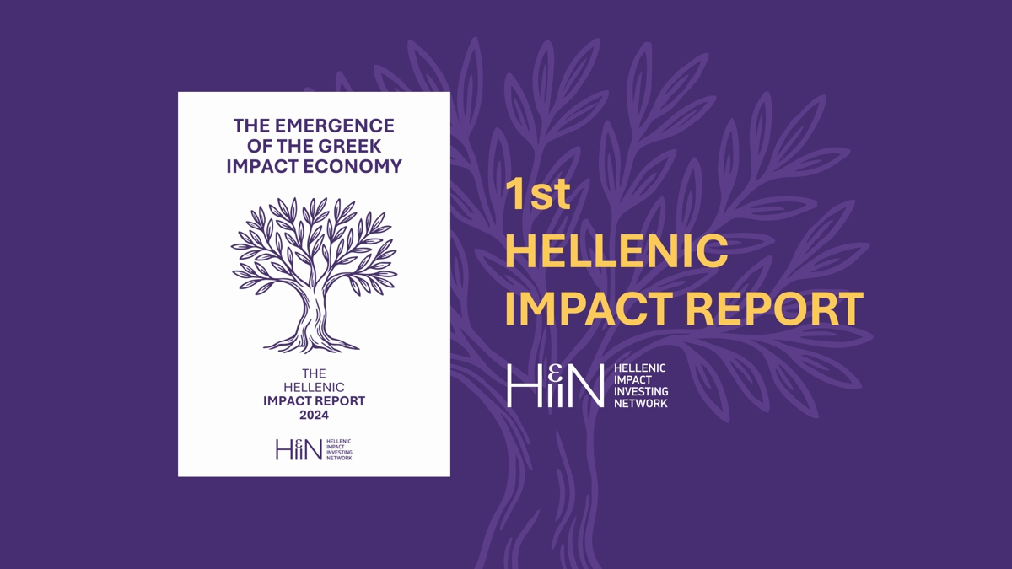

**Greece’s inaugural National Impact Map & Report charts a pragmatic path to sustainable finance**

As the world navigates intersecting crises, climate change, biodiversity loss, inequality, and demographic shifts, capital markets are increasingly expected to contribute solutions rather than exacerbate problems. In Greece, these challenges are intensified by a fragile environmental landscape, social inclusion gaps, and a need to align national development with the European Green Deal.

Impact investing, defined as the deployment of capital with the intention to generate measurable social and environmental benefits alongside financial returns, offers a credible pathway to align economic growth with sustainable and inclusive development. Greece’s impact investing ecosystem is still nascent but evolving rapidly, and this report represents a first coordinated step toward understanding and advancing it. The Hellenic Impact Report aims to provide a shared foundation for dialogue, collaboration, and action across the ecosystem.

The HIIN today announces the release of the first Hellenic Impact Investing Map and Report, a milestone in Greece’s path of developing its local Impact and Sustainability Ecosystem.

Led by the Hellenic Impact Investing Network (HIIN), the country’s National Platform for Impact Investing under the global organization GSG Impact, a global network with more than 50 countries, this report has been strengthened by the voices of thought-leaders across the industry. The report further benefits from the invaluable support of prominent international collaborators, including the European Commission, European Investment Bank Group, European Investment Fund, EBRD, Hellenic Development Bank of Investments, Enterprise Greece, Elevate Greece, GSG Impact and Impact Europe.

This landmark publication signals the country’s inaugural attempt to survey, document, analyse and compare how the Greek impact and sustainability ecosystems are evolving. It is the first coordinated effort to establish a factual baseline, present an actionable roadmap, and maintain constant reflection on the UN Sustainable Development Goals. The report’s quantitative insights feed directly into Europe’s wider impact-mapping initiative, ensuring that Greece’s progress informs continental policy and investment strategies.

*“Greece has the potential to become a leader in impact investing across the European periphery and for this we need a dedicated Impact Law, scalable blended finance structures and new thematic impact investing products to translate ambition into investable opportunities. We must empower our ecosystem and support ecosystem builders like the HIIN that foster collaboration among public, private, and philanthropic actors.”*

**Kostis Tselenis**

**Board Chair, Hellenic Impact Investing Network**

**Managing Partner, Swiss Impact Office**

The global impact investing market has crossed the USD 1 trillion mark, but capital remains concentrated in a handful of markets. HIIN’s research shows that Greece’s current economic development paired with entrepreneurial talent, exceptional climatic conditions, natural capital and strategic EU position can attract a larger share of this rapidly growing market. This report provides useful insights to investors, policymakers and the broader investment and sustainability ecosystem to allow for optimal decision making and the advancement of the market.

This report offers Greece’s first structured mapping of impact actors, capital flows, and investment activity, spanning start-ups, funds, corporates, public institutions, ecosystem builders and non-profits. It highlights where capital is already contributing to positive outcomes, such as in renewable energy, circular economy, and inclusive finance, while also pointing to persistent structural barriers. Drawing from lessons in more developed ecosystems, the report proposes a practical roadmap to help mobilize capital, strengthen impact measurement, and support ecosystem growth over time. It aims to provide a common reference point to support collaboration, inform decision-making, and connect Greece more closely to the international impact community.

**WHAT THE REPORT REVEALS – 5 KEY INSIGHTS**

**Over €10 billion** in impact investments already mobilised across Greece, including EU and foreign capital—of which €1.8 billion is sourced from domestic investors.

**Only 12% of investors** report having formal impact measurement systems, highlighting the need for market-wide capacity building.

**Environmental themes** dominate the current agenda, but attention to **social inclusion** is growing—essential for balanced and inclusive development.

**44% of impact-driven startups** have less than 5 full-time equivalent employees.

**Venture Capital / Private Equity** is the primary instrument used, in line with European trends, but more catalytic and patient capital tools are needed to unlock scale.

**PRACTIONIER VOICES**

*“Greece has a great potential for impact investing; it is a developing market backed by a vibrant community of entrepreneurs, innovators, and regional networks.”*

**Brigitte Fellahi-Brognaux - Head of Unit, Social and Inclusive Entrepreneurship, Directorate General for Employment, Social Affairs and Inclusion, European Commission**

*“One of our jobs is to create the pathways and incentives for this capital to be directed to positive, measurable impact in every country. The recent and rapid rise of social entrepreneurship in Greece shows the quality of the demand and the opportunity. This report further highlights that opportunity.”*

**Elizabeth Boggs Davidsen - CEO, GSG Impact**

*“Greece is taking decisive steps to address climate change and build a greener economy. We view sustainability not just as a challenge but as an opportunity—an opportunity to innovate, attract investment, and improve the quality of life for all Greek citizens”*

**Zoi Rapti - Deputy Minister of Development 2024, The Hellenic Republic**

*“Greece’s recovery phase presents an important opportunity to embed sustainability into the core of investment decision-making. HDBI plays a key role in this transition. We aim to support the development of a more structured and transparent ecosystem in Greece, by anchoring fund strategies that align with value creation and long-term societal outcomes.*

**Antigoni Lymperopoulou - Chief Executive Officer, Hellenic Development Bank**

*“The Greek ecosystem has come a long way since we made our first venture investments in 2021-2022."*

*“NGOs and social enterprises, especially those combating the climate crisis and promoting social engagement, can explore new ways to achieve financial independence without relying solely on grants. Both investors and philanthropists can play crucial roles in addressing these challenges.”*

**Alex Zitrides – Managing Director, The Helidoni Group**

*“The Greek impact ecosystem needs to be closely linked with the larger impact investing market in Europe and the US. Our ecosystem stakeholders need to learn from the best. Impact investing transcends assets classes and profit expectations.”*

**Antonis Schwarz *-* Founder, Good Move Initiatives**

*“The purpose of the EIF call for tender with EquiFund II is to scale existing impact initiatives in Greece. This call is specifically designed in coordination with the Greek authorities for the benefits of the Greek market.”*

*“Deal flow is essential. Organizations like the HIIN play a crucial role first by bringing together a community of like-minded impact investors of the Greek ecosystem, and second by launching various initiatives that have positive spill over effects on the market”*

**Cyril Gouiffès - Head of Social Impact Investments, European Investment Fund (EIF)**

*“Greece is already taking significant steps to ensure that the Blue Economy aligns with global sustainability goals, particularly in marine biodiversity and climate resilience. Greece has secured EUR 780m in funding for marine and climate-related commitments”*

**Dionysia-Theodora Avgerinopoulou - Special Envoy of the Prime Minister for the Oceans, Hellenic Republic**

*“Greece has taken significant steps to integrate ESG standards into both national policies and the domestic business culture, establishing a robust foundation for long-term, impactful growth.”*

**Marinos Giannopoulos - Chief Executive Officer, Enterprise Greece**

*“One of the main challenges for impact ventures in Greece is securing early-stage funding, particularly for businesses addressing sustainability and social challenges. However, the opportunities are significant, especially as Greece continues to emerge as a hub for innovation in areas like clean tech, social enterprises, and the blue economy.”*

**George Platanas - Managing Partner, Seedraised, HIIN Board Member**

*“We need to intercept a large number of potential beneficiaries. This will involve a series of awareness-raising initiatives like webinars and seminars to identify who could benefit from EIB’s Impact Investing Capacity Building Initiative”*

**Bruno Robino - Deputy Head, Advisory Financial Institutions Division, European Investment Bank (EIB)**

*“Southern Europe faces shared structural challenges, but also holds rich potential through deep social innovation and a growing appetite for purpose-driven finance”*

**Alessia Gianoncelli - Director of Knowledge and Insights, Impact Europe**

*“Elevate Greece evaluates and highlights the impact potential of startups by taking into account the positive side effects of their products and solutions”*

**Fragiskos Theofylaktos - Chief Executive Officer, Elevate Greece (2024)**

*“EBRD’s strategic priorities in Greece are sustainable infrastructure and a greener energy mix, a competitive private sector, small and medium-sized enterprise (SME) growth and a resilient financial sector.”*

**Angeliki Kalligiannaki - Head of Greece, European Bank for Reconstruction and Development (EBRD)**

**Dimitris Chatziiakovou - Principal, European Bank for Reconstruction and Development (EBRD)**

**KEY STATEMENTS AND STRATEGIC FINDINGS**

**What the Data Tells Us: Turning Point for Greece’s Impact Market**

“In 2024, impact-related investments in Greece exceeded EUR 10 billion, combining EU funding, foreign capital, and EUR 1.8 billion in domestic commitments, driven primarily by green infrastructure. This marks a pivotal moment for a young ecosystem that is quickly gaining scale and credibility.”

“Venture Capital and Private Equity are the leading vehicles for impact capital in Greece, reflecting similar patterns observed across the European market.”

“While the market is growing, only 12% report formal Impact Measurement and Management (IMM) practices, highlighting a clear area for ecosystem maturation.”

“Environmental themes dominate the current impact agenda, but a gradual shift toward social inclusion is emerging—critical for fostering balanced, inclusive development.”

**SUPPLY OF IMPACT CAPITAL**

**Unlocking Capital: Who’s Financing the Transition?**

Greece’s impact investing landscape remains nascent but shows clear momentum. Over 60% of surveyed investors incorporate sustainability criteria in their decision-making, and dedicated impact strategies are beginning to take shape. Public actors such as the European Investment Fund (EIF), Hellenic Development Bank of Investments (HDBI), and Recovery and Resilience Facility (RRF) are driving supply through anchor initiatives, while private capital remains cautious but increasingly interested. A more structured market architecture, through blended finance, outcome-linked products, and clearer regulation, will be key to unlocking institutional participation at scale.

Over 60% of investors say they integrate sustainability into their investment processes.

Only 12% of investors report having a formalised impact measurement system.

64% of investors invest through venture capital and private equity, reflecting the dominance of these asset classes in impact ecosystems worldwide.

**DEMAND FOR IMPACT CAPITAL**

**What the Market Needs: Startups, Scale, and Solutions**

The report identifies strong and growing demand for impact capital across sectors such as renewable energy, sustainable food systems, circular economy, and inclusive technology. Impact ventures typically operate in nationally strategic sectors such as responsible consumption, green cities, and waste management, yet continue to face structural barriers in attracting institutional capital. The most pressing capital needs include working capital, seed and venture-stage equity, and structured finance for project scaling. These gaps reveal a clear opportunity for mission-aligned capital to step in, and for Greece to build financing structures that reflect the depth and diversity of its impact ecosystem.

70%+ operate in priority sectors like food, waste management, energy, tourism, and tech.

Only 20% of ventures report access to blended capital.

Most common financial needs: working capital, seed equity, and project-scale funding above €1M.

67% of startups are located in the Athens region, reflecting the stark centralisation of venture activity.

**SECTORAL OPPORTUNITIES**

**Sectors to Watch: Where Impact Capital Can Lead?**

Greece’s impact economy is anchored in advanced sectors like renewable energy and green infrastructure, where large-scale investments are already reshaping the energy landscape. Promising frontiers include offshore wind, sustainable aquaculture, regenerative tourism and generally the blue economy, all gaining traction through EU-aligned policies and international capital. Nature-based solutions and reforestation efforts are also showing early stage momentum, backed by dedicated public programmes. Meanwhile, strategic sectors such as green shipping decarbonisation and sustainable food systems are beginning to attract investor attention, offering strong potential for scale and innovation. The country’s social enterprise ecosystem is expanding rapidly, albeit from a low base, driven by inclusive entrepreneurship and growing institutional support.

**POLICY AND REGULATION**

**The Policy Shift: Designing the National Impact Law**

Greece has taken important first steps to align its regulatory landscape with the evolving European framework on sustainable finance. From the EU Taxonomy and the Sustainable Finance Disclosure Regulation (SFDR) to national climate targets and green investment initiatives, the foundations are being laid. The Hellenic Impact Investing Network (HIIN) advocates for a National Impact Law, structured blended finance mechanisms, and improved access to public funding for early-stage and high-impact ventures. These steps can help Greece unlock long-term capital, further align with EU standards, and become a leading regional hub for sustainable and inclusive finance.

These insights will be unpacked at the upcoming [3rd Hellenic Impact Investing Conference (HIIC25),](http://www.impactconference.gr) Greece’s premium international forum dedicated to sustainability and impact investing. Organized by the HIIN and global partners, HIIC25 convenes global and regional leaders, investors, policy makers, entrepreneurs, experts and academia, to translate findings into action, accelerate partnerships, and co-design the future of sustainable investing in Southeast Europe.

**ABOUT THE HIIN – THE NATIONAL PLATFORM OF GREECE**

The Hellenic Impact Investing Network is Greece’s officially mandated National Platform for Impact Investing under the global organization GSG Impact, a coalition of over 50 countries committed to aligning finance with sustainability and social purpose. The HIIN’s mission is to mobilise capital for a sustainable and inclusive future by connecting Greek and international stakeholders across finance, policy, philanthropy, and entrepreneurship. Its vision is to catalyse positive, measurable change through impactful investments that support a flourishing society, economically, socially, and environmentally.

The HIIN plays a central role in shaping the domestic ecosystem. It translates global frameworks into national standards, contributes to EU-level working groups on regulation (such as SFDR and blended finance), and partners with the local ecosystem to unblock capital bottlenecks. Its landmark initiatives include the [Hellenic Impact Investing Conference (HIIC)](http://www.impactconference.gr), the national impact mapping effort and the 1st Hellenic Impact Report, the upcoming Impact Management and Measurement Framework for Greece, the planned contribution into the design and launch of a National Impact Law for Greece, and the support of new impact fund initiatives and ventures. In 2024, the HIIN was recognized for its ecosystem building work and was invited to join the official Greek state delegation to COP29 in Baku, where it presented suggestions for Greece’s positioning on energy transition and nature-based solutions, and announced new verticals like the Mediterranean Forest Impact Investing initiative.

The organization’s governance is guided by a 14-member Advisory Board composed of exceptional personalities from finance, philanthropy, and civil society, from Greece and abroad. Operational delivery is structured around nine strategic verticals, from policy reform and measurement standards to family capital, innovation, and venture support.

Everything the HIIN does is designed to translate catalytic support into capital for good. We pledge that every euro of core support can mobilise up to EUR 1,000 of aligned local and international investments into high-impact ventures and strategies. Through investor education, venture acceleration, knowledge platforms, and market-building efforts, the HIIN aims to act as a high-leverage force for sustainable transformation in Greece.

We welcome aligned institutions, sponsors, and philanthropic partners to join this effort. Together, we can put Greece at the forefront of impact investing in the region, and ensure that sustainability becomes the standard, not the exception.

**Read the full Hellenic Impact Map Report**

[www.thehiin.org/impactreport](http://www.thehiin.org/impactreport)